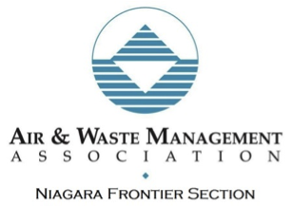
2019 Earth Day Grants
Applications Due: March 29, 2019
Contact Peter Grasso (Education Chair) at awmanfs.education@gmail.com
The Air & Waste Management Association – Niagara Frontier Section (A&WMA-NFS) will again be awarding one or more grants worth up to $500 each in honor of Earth Day 2019. The program promotes environmental awareness through creative and impactful educational activities and community engagement efforts.
Eligibility:
• The grant is open to educational institutions and community organizations in New York State counties of Allegany, Cattaraugus, Chautauqua, Erie, Niagara, and Wyoming. This is intentionally broad! We hope to fund great ideas that seek to dramatically improve environmental awareness in the WNY community.
Grant Conditions:
• Funds must be used between April 1, 2019 and March 31, 2020.
• After completion of the Earth Day project/event, grant recipients must submit a brief letter/email report to the A&WMA-NFS Education Chair that includes a summary of the project (photos of the project are encouraged).
• All marketing efforts for the funded project must clearly acknowledge financial support from AWMA-NFS.
Application Requirements:
• Applicants must provide all requested information (refer to page 2, below)
• The application must contain a detailed budget justification
• Submit Applications to Peter Grasso by email: awmanfs.education@gmail.com
• Applications must be e-mailed no later than March 29, 2019 (midnight).
• Questions regarding the Earth Day Grant Program should be directed to Peter by e-mail.
• Applications will be reviewed by a predetermined AWMA-NFS committee, and the grant will be awarded by the Education Committee. The decision of the committee is final.
Application Information:
Project Name:
Organization Name:
Street Address:
City: |  | Zip Code:
Name of Project Coordinator:
Telephone Number:
Anticipated Number of Participants:
Amount of Grant Request ($):
Provide a brief (less than 2 page) project description that includes a summary of activities, anticipated schedule, location, detailed budget justification, and any other important details for the reviewers to consider.

